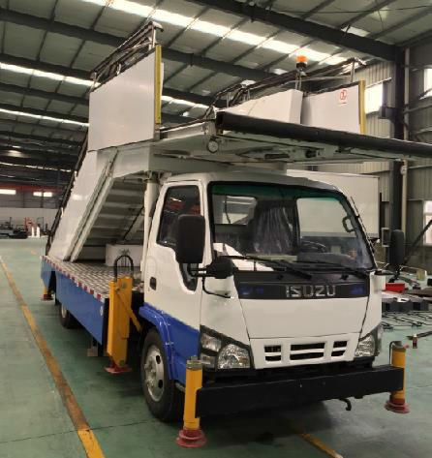

TRUCK MOUNTED PASSENGER STAIRS AVS5060

Our Truck Mounted Passenger Stair AVS5060, is designed to be hydraulically operated and controlled from the driver’s seat. It is designed and engineered to service all aircraft with doorsill heights between 2400 and 5800mm. This model is available with many options to meet your specific operational needs.

Design and Manufacture Standard:
ZB/T50 001—87 Special vehicle Prototype Testing regulation JB/T5943—91 Engineering Machine Welding General technical requirement IATA AHM—913 Basic safety requirement of Aircraft ground Support Equipment IATA AHM—910 Basic requirement of the Aircraft Support Equipment
IATA AHM—915 Standard Control Device
SAE--ARP836A Design and Safety requirement of Aviation Passenger Stairs Truck

1.0 Standard Dimensions
  - Overall length 7610mm
  - Overall height, lowered 3780mm
  - Overall width 2320mm
  - Step Length 1500mm
  - Step height 180mm
  - Step depth 270mm
  - Platform length 2800mm
  - Platform width 1500mm
  - Minimum floor height 2400mm
  - Maximum floor height 5800mm
  - Max load fixed steps: 1950kg
  - Max. load intermediate platform: 485kg
  - Max. load moveable stairs: 1690kg
  - Max. load Upper platform: 1400kg
  - Shipping weight 7200kg

2.0 Vehicle side and rear of chassis
  - Chassis: ISUZU QL1070A5KAY (600P);
  - Engine: 4HK1CN5HS Diesel Engine; 4 in lines; EUV
  - GVWR: 5909 kg
  - Wheelbase: 3815 mm
  - Manual transmission, with 5 forward speeds and 1 reverse for the gear box.
  - Heavy duty alternator and battery
  - Power steering
  - Power brake

3.0 Hydraulic System
  - PTO driven hydraulic pump/electric clutch
  - Directional control in cab
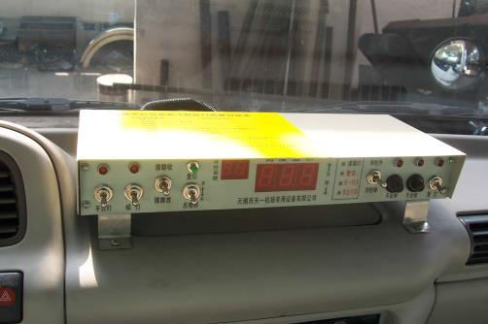
  - Auxiliary hand pump for emergency retraction

4.0 Electrical System
  - 12 volt chassis
  - Engine hour meter
  - Fully illuminated steps and platform

5.0 Constructions
  - Primary structure, steel
  - Side panels, aluminium
  - Steps and platform, non skid aluminium plate
  - Stainless steel railings
  - Rubber bumpers located on platform forward edge
  - Protected by epoxy based primer and polyurethane paint
  - Canopy
  - Red carpet for VIP

6.0 Safety Protection
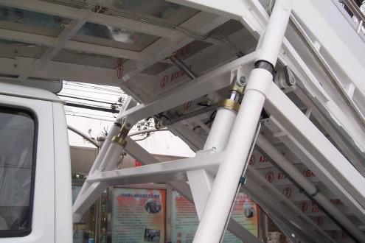
  - Electro-light switch for contact alarm.
  - Hydraulic interlock assembly
  - Anti-collapse Damper on front platform
  - Leveling control from the platform
  - Buzzer and Light Alarm for lifting and lowering protection
  - Digital display for visual operation protection
  - Indication light for stabilizers operation
  - Emergency manual pump
  - Beacon light

7.0 Options
  - Adjustable front platform extends 300mm
  - Swivel bumper
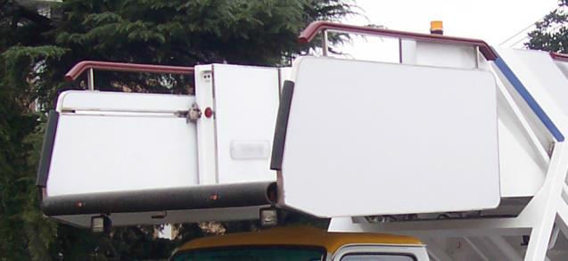
  - Gauge light
  - Win screen washer
  - Duplicate controls (electric) from top platform
  - Canopy lighting
  - Additional paint colors of stabilizers
  - Motor pump unit

8.0 Aircraft Compatibility
This passenger stairway is capable of servicing: A-300-600, A-310, A-318,A-319, A-320, A-321, A-330, A-340,A350,A380, B-707-320B, B-727, B-737, B-747, B-747-SP, B-757, B-767, B-777,B787, DC8, DC10, L-1011, MD-11, TU-154,TU-154B aircraft.

