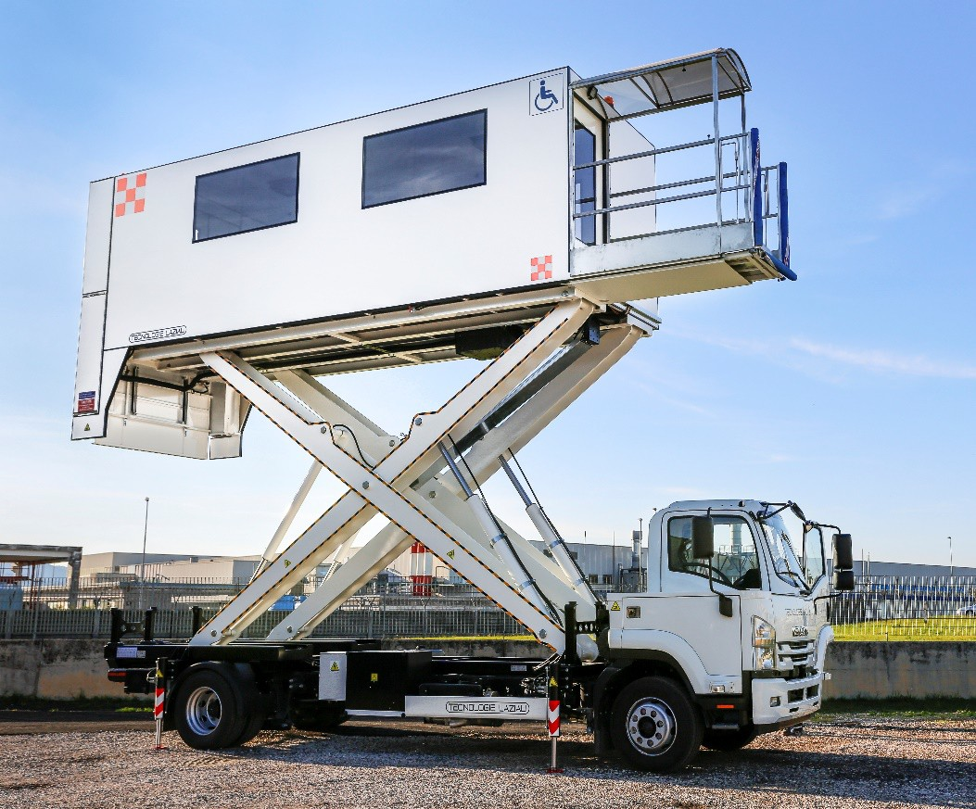

HALF CABIN AMBULIFT HCTLZ5800
CAPACITY: 2000 kg OPERATIVE RANGE: 1650/5800 mm
Ambulift on ISUZU F14NQ (or on request a similar IVECO vehicle), has been designed for the transport of disabled people in wheelchairs and on stretchers sick from ground level.

HALF CABIN AMBULIFT HCTLZ5800

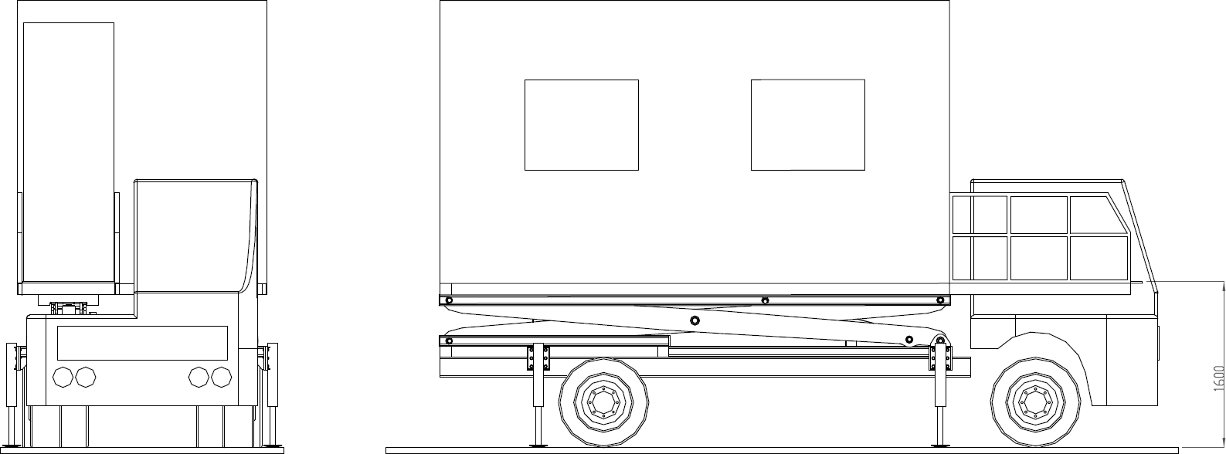

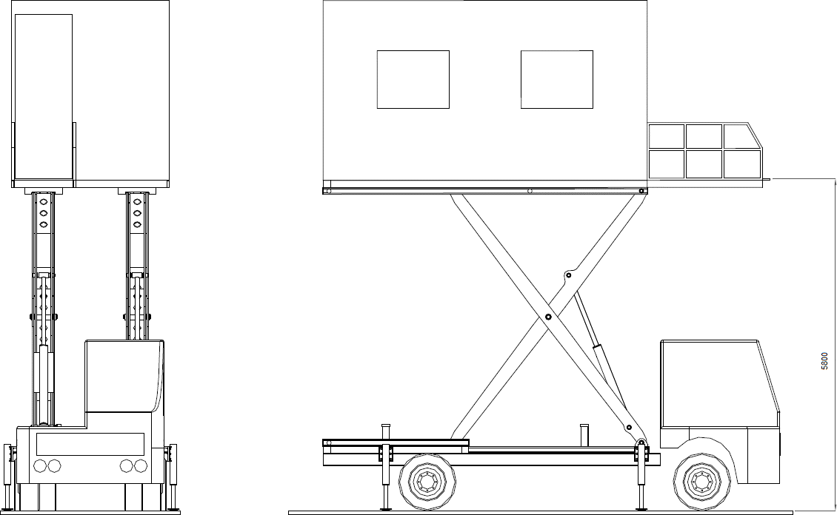

TECHNICAL SPECIFICATION
Truck ISUZU F14NQ  Wheelbase 5320 mm  Overall width 2500mm  Height 4090 mm  Total Length 8900 mm | Minimum height from ground (with stabilizer feet) 1650 mm Maximum height from ground (with stabilizer feet) 5800 mm Operating speed max 30 Km/h  Max wind speed 74 Km/h
Sizes vanbody (external) | Sizes of the platforms
Width 2290 mm  Height(without air cond. system) 2270 mm Length 6900 mm  Capacity Vanload 2000 Kg  (9 passengers in wheelchairs and 2 assistants, or 4 stretchers and 2 assistants) | Front | Rear
 | Width 850 mm  Length 1800 mm  Longitudinal movement 500 mm Working height 1650 mm  Capacity 454 Kg | Width 2200 mm  Length 1700 mm  Working height to floor 0-1600mm Capacity 700 Kg

