**NTE**

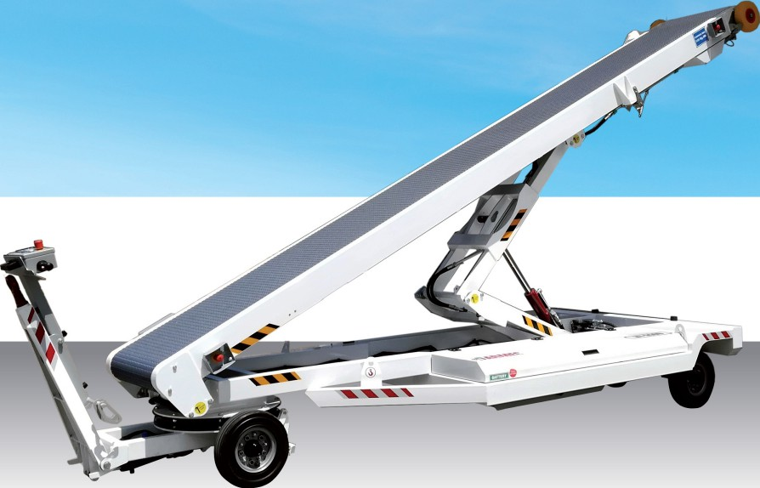

**NT550E NT645E NT725E**

**NTBooE**

The towed conveyor belts loader are designed to load baggage and goods inside the aircraft hold; they are built on a sturdy chassis with a fixed rear axle and a rigid front axle connected to a rotating bearing coupling with tow bar and hook. The axle is equipped with a brake pad which comes activated by raising the tow bar in a vertical position and which is automatically operateci in case of accidental unhooking. Depending on requirements, the conveyor belt can have a length from 5500 mm to 8000 mm.

The **NT** series is equipped with acetal resin modular belt with elastomer grip surface.The special feature of belt allows a high drainage capacity, minimizes water deposits and the possible formation of ice; it does not require tensioning and allows quick replacement even of small sections, thereby offering multiple benefits in terms of time and maintenance costs. The vehicle is powered by a 24V 250 Ah battery. On request, the equipment can be equipped with a motorized wheel and will include the

most modern safety and damage prevention systems, including turtle and snail speed plus approaching; ultrasonic distance sensor for aircraft revelation and bumpers with sensor.

Optional extras include fixed or fold-down handrails H = 1000 mm, fixed or fold-down guide rails in aluminium H = 100 mm.

**NTE**

**NT550E NT645E NT725E**

**NTBooE**

|  |  |  |  |  |  |  |  |  |  |  |  |  |  |  |  |  |  |
| --- | --- | --- | --- | --- | --- | --- | --- | --- | --- | --- | --- | --- | --- | --- | --- | --- | --- |
|  |  | A | **B** | e | **D** | **E** | **F** | G | **H** |  |  | K | **L** | **M** | **N** | **o** | Mass |
| **NTssoE** | 6972 | 1880 | 1400 | 860 | 3795 | 1834 | 740 | 260 | 1083 | 795 | 2950 | 600 | 745 | 5500 | 1320 | 1570 |
| **NT645E** | 7922 | 1880 | 1400 | 860 | 3795 | 1834 | 740 | 260 | 2033 | 795 | 3400 | 600 | 745 | 6450 | 1320 | 1650 |
| **NT725E** | 8977 | 1880 | 1400 | 860 | 4624 | 1834 | 740 | 630 | 1889 | 795 | 3600 | 600 | 745 | 7250 | 1320 | 1850 |
|  | **NTSooE** | 9527 | 1880 | 1400 | 860 | 4624 | 1834 | 740 | 630 | 2439 | 795 | 3390 | 600 | 745 | 8000 | 1320 | 1850 |

Dimensions expressed in mm '' Rear lifting scissor (option)

**OTHER OPTIONAL**

* Fixed or fold-down handrails 1000 mm
* Fixed or fold-down guide rails 100 mm
* Canopy
* Customization upon client's request

This catalogue should be revised to match a standard web product design on a blank sheet

