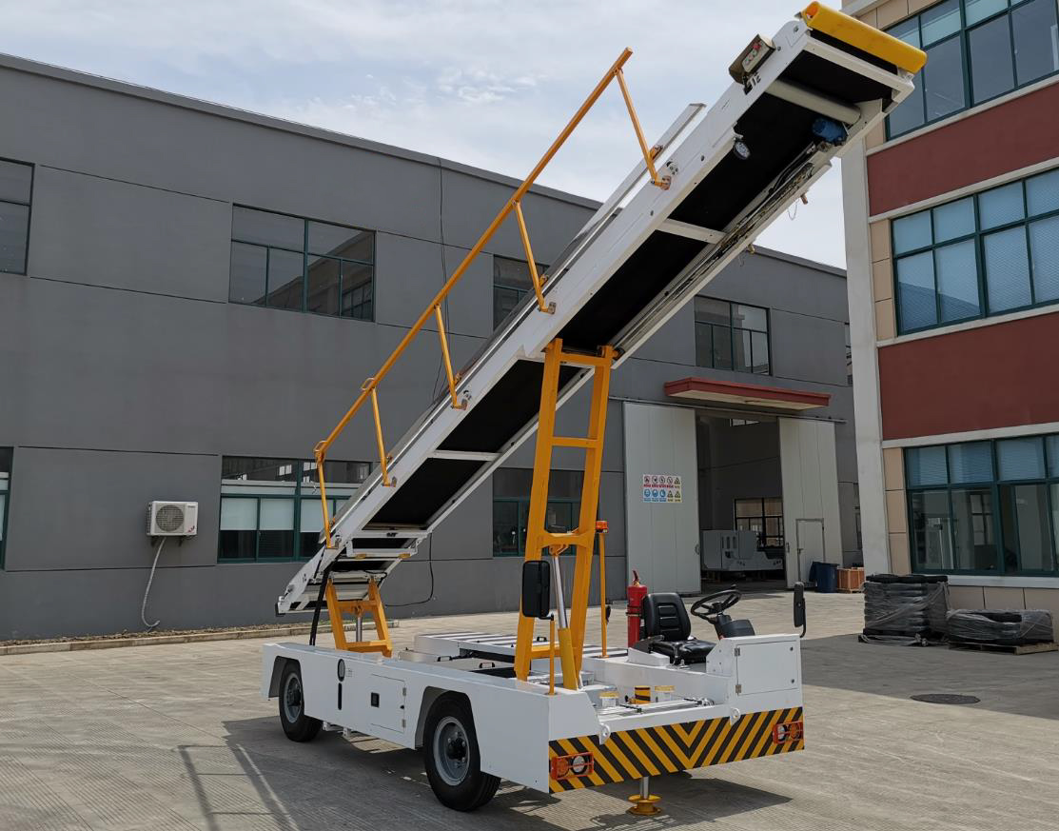
SELF-PROPELLED CONVEYOR BELT LOADER
AVSSPCBL80

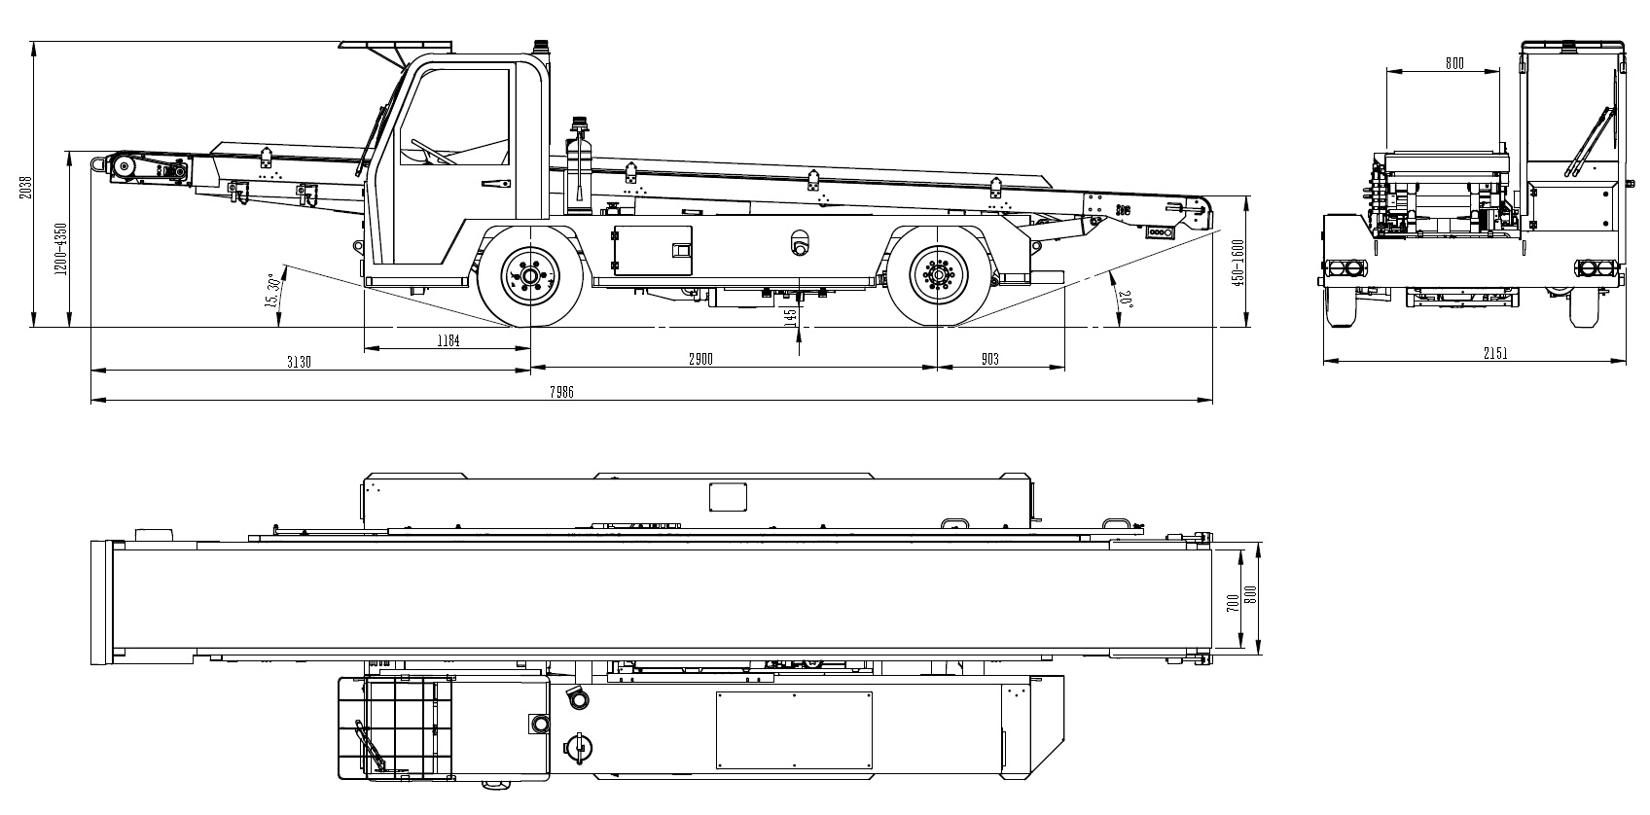

TECHNICAL SPECIFICATION

Introduction
Our Self-propelled Conveyor Belt Loader is among the most up-to-date design of Belt Loaders on the market. It is a universal type that suits all aircraft cargo and luggage service in airports. It is reliable in performance and easy for operation and maintenance.

Equipment Standard
IATA AHM 905 Reference Material of Civil Airport Terminals
IATA AHM 910 Basic Requirement of Airport Ground Support Equipment
IATA AHM 913 Basic Safety Requirement of Airport Ground Support Equipment
IATA AHM-925 Technical Requirement of Self-propelled Conveyor Belt Loader
MH/T 6030-2014 Bulk Cargo and Luggage Belt Loader
AC-137-CA-2015-17 Testing Regulation of Self-propelled Conveyor Belt Loader

Work Conditions
Altitude: ≤3000 m
Ambient Temperature: -40℃～+65℃

Technical Parameters
Overall Dimension: 8000×2100×1650 mm
Min. Turning Radius: 6500 mm
Wheelbase: 2900 mm
Front Wheel tread: 1725 mm
Rear Wheel tread: 1695 mm
Max Grade ability (°): 30
Ground Clearance: 145 mm
Shipping Weight: 3200 kg
Belt Width: 700 mm
Boom Length: 8000 mm
Conveying speed: 0.2 - 0.5 m/s
Max distribution load of conveyor belt: 135 Kg/m
Work height range of front end: 1200-4300 mm
Height range of rear conveyor end: 1600-450mm
Max Inclination angle: 29°
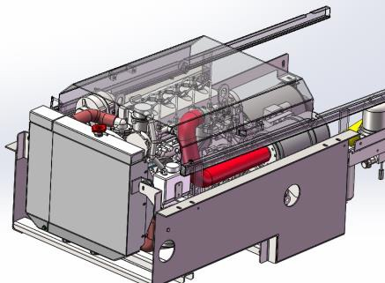
Main Structure and Configuration
o Power and Transmission System

CUMMINS DIESEL ENGINE
Engine Model：QSF2.8t3Na49
Type: Four cylinders, Four strokes, Water coolant,
Straight line, EU Stage IIIA emission standard

Power diagram

Displacement: 2.8 L
Max Output capacity: 36.5/2500 rpm
Max output torque: 186 Nm / 1100 - 1500 rpm
The engine isequipped with USA original Horton fan with famous brand large capacity aluminum fin type radiator, large capacity water filling tank and large capacity air filter.

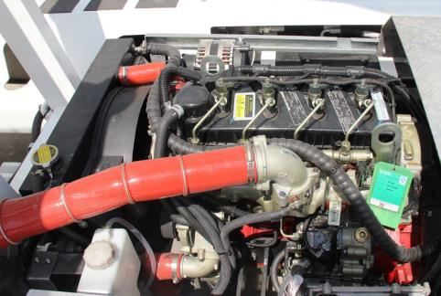
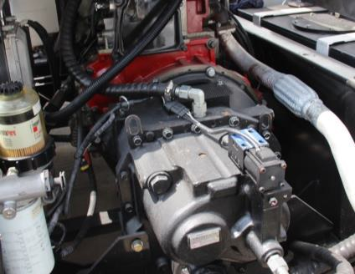
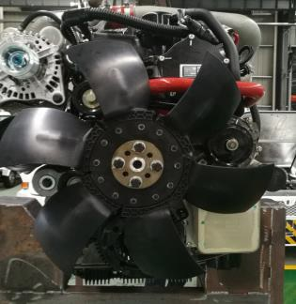

GRAZIANO PST2 AUTOMATIC TRANSMISSION
Model: PST2, Italian brand
Type: Hydraulic automatic transmission, single stage torque converter, 2Phase, 3 components comprehensive type, simple structure and stable performance.

o Tractor Axles, Tires, Brake system

1. Front Axle:
Type: Steering axle with hydraulic disc brake, single-side double-clamp twin cylinder brake, with pay load of 3ton.

With Front axle with steel plate spring absorber system for option

2. Rear Axle:
Type: Driving axle with drum type walking brake and parking brake, with 3Ton pay load.
3. Wheel Type: Radial type, Steel Wiring Tire, 7.00R15
4. Brake system: 8 + 9 Inch Vacuum Power assisted system

o Electric System

12V DC Electric system, negative grounded
80Ah Maintenance Free Battery, LED Light for Complete vehicle including Head light, CAN Wiring device, High qualified vehicle gear shifter, Germany original Weidmueller Relays.
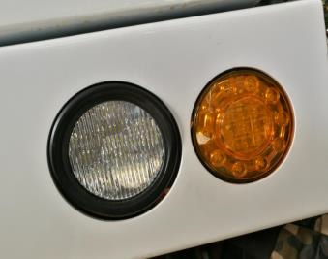
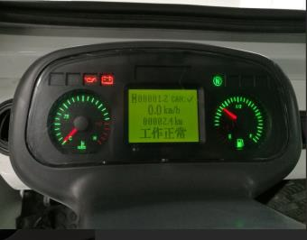
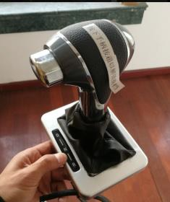
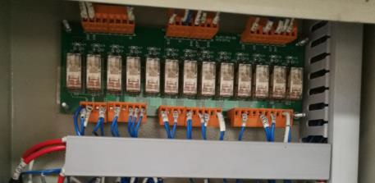

Electric lay-out
o Hydraulic System

The hydraulic system consists of main configurations as below:
1) 90L Hydraulic Tank
2) Chinese best branded Hydraulic pump
3) Italian branded HV hand pump
4) EATON hydraulic valve sets, Italian OM Piping valves, best Chinese Card connector and hydraulic pipe as well as Parker soft hydraulic pipes.

The hydraulic system is available with the emergency retrievable stabilizer and the emergency lifting & lowering function for both front and rear lift frame. The complete piping design is a hard type so that it keeps the same long time as the vehicle operation.
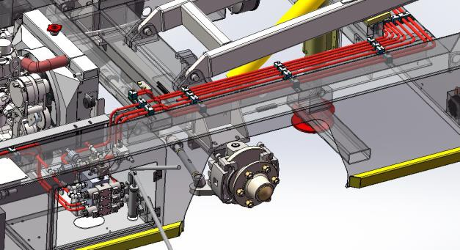
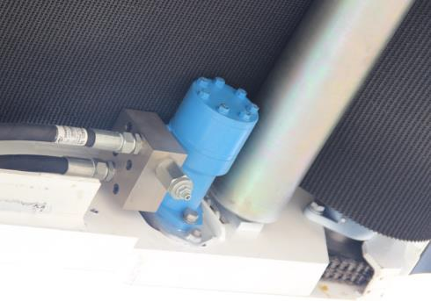

Hydraulique components and lay-out Diagram

o Conveyor Frame Part

The conveyor frame consists of a main frame in width of 800mm, heavy loaded type rollers, drive rollers, driven rollers, adjusting rollers, drive motors, etc.
1) The front drive roller is a PU rubber packed in diameter of 210mm, which provides adequate friction and have long service life.
2) The rear end is belt tension assembly with 160mm adjusting range for forward and back, which makes the conveyor belt easily disassembled and maintained.
3) The load rollers are in thickness of 2mm. The distance between both front and rear ends is 700mm which can prevent luggage not being crashed during transportation. The middle distance is 180mm which makes it easy for maintenance.
4) The belt width is 700mm, thickness 8mm, three-layer type that is famous Taiwan NANG brand. There are two sets of conveyor deviation correcting devices installed at lower end to ensure it running in right track without any deviation.
5) Front hydraulic motor as a driving system can provide maximum conveying power. It can transport a maximum of 1200KG of cargo or luggage.
6) There are stainless steel guiding baffles at the two sides of the conveyor frame so as to prevent luggage dropping off. The right-side baffle can be foldable together with the handrails. The handrail height lifted is 850mm.

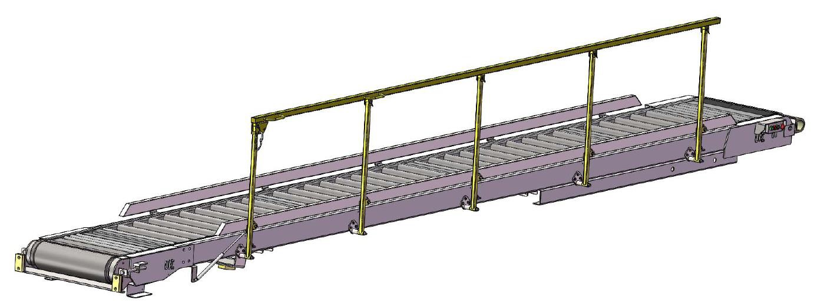
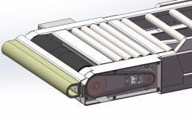
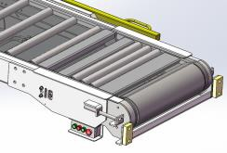

Conveyor frame illustration diagram

Options

o Waterproof Canopy on conveyor
o Cool/Heat Air Conditioner
o Heater in driver’s cab
o Webasto heating system
o Driving Recording Unit
o Front Stabilizer
o Front Axle Absorption System with two front stabilizers

