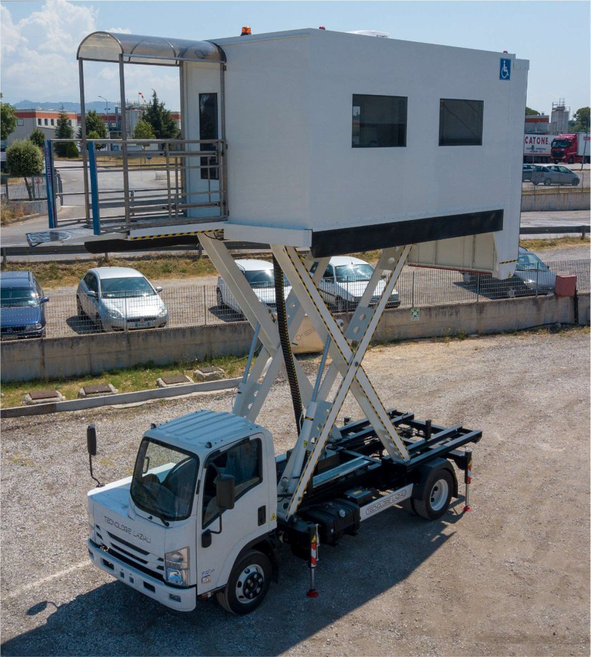

HALF CABIN AMBULIFT HCATLZ 4500
CAPACITY: 2000 kg
OPERATIVE RANGE: 1600/4500 mm
Ambulift on ISUZU P75-K (or on request a similar IVECO vehicle), has been designed for the transport of disabled people in wheelchairs and on stretchers sick from ground level.

HALF CABIN AMBULIFT HCATLZ1645

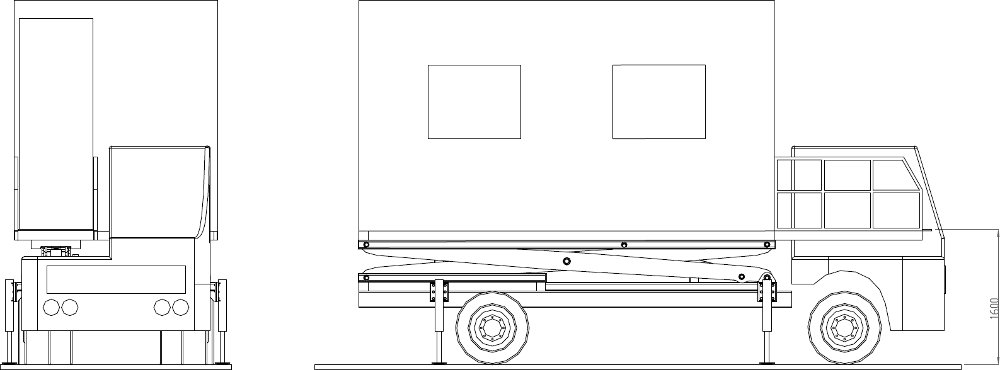

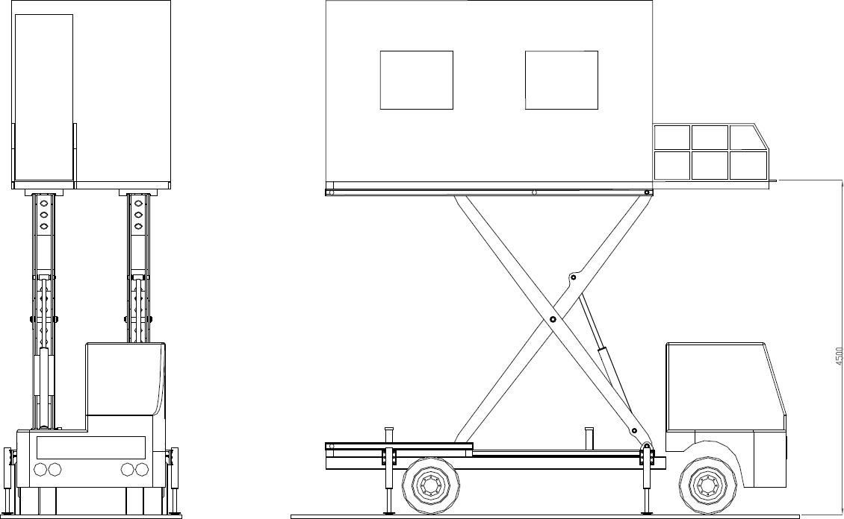

TECHNICAL SPECIFICATION
Truck: Isuzu P75-K  Wheelbase 3815 mm  Overall width 2500mm  Height 3975 mm  Total Length 6500 mm | Minimum height from ground (with stabilizer feet) 1600 mm Maximum height from ground (with stabilizer feet) 4500 mm Operating speed max 30 Km/h  Max wind speed 74 Km/h
Sizes vanbody (external) | Sizes of the platforms
Width 2450 mm | Front | Rear
Height(without air cond. system) 2330 mm | Width 900 mm | Width 2200 mm
Length 4500 mm | Length 1650 mm | Length 1700 mm
Capacity Vanload 2000 Kg  (6 passengers in wheelchairs and 2 assistants, or 2 stretchers and 4 passengers in wheelchairs and 2 assistants, or 10 people standing and 2 assistants) | Longitudinal movement 500 mm Working height 1600 mm  Capacity 454 Kg | Working height to floor 0-1600mm Capacity 700 Kg

