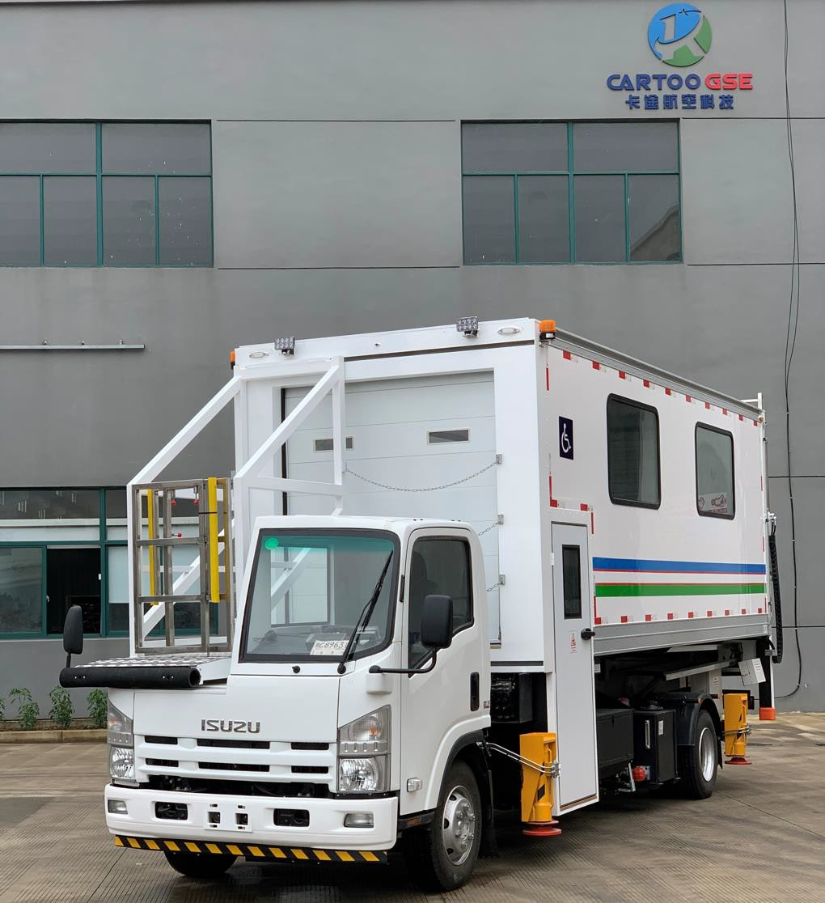

HALF CABIN AMBULIF HCAMB5800

I. DESCRIPTION

Our Ambulift is designed and built to lift disabled passengers from ground level to the main cabin of narrow body and wide body aircraft. This model is available with many options to meet your specific operational requirements. This equipment is designed to withstand the airport complex environment, simply to operated and easy to maintain.

II. STANDARD COMPLIANCE

- AHM910 Basic requirement of aircraft ground service equipment
- AHM913 Basic safety requirement of aircraft ground service equipment
- AHM915 Standard control devices
- AHM979 Function regulation of disabled passenger boarding truck
- GB/T31028-2014 Disabled passenger boarding truck
- JG5099-1988 Safety regulation of aerial working machine
- GB7258-2004 Safety technical requirement of vehicle operation

- WORKING CONDITION
Elevation: ≤3000 m
Ambient temperature: -40℃ ～+65℃

- STANDARD DIMENSIONS
  - Overall Dimension(L*W*H): 8990*2460*3770 mm
  - Front Platform height from the ground: 1500-5800mm (for Half Driver’s cab type)
  - Length (including forward extension): 1950mm, width of moving section: 830, movement of the moving section (Left-Right): 1000mm
  - Telescopic section width: 760mm, Telescopic length: 700mm
  - Forward/backward extension of telescopic section platform: 0-500mm
  - Left/Right movement of platform: 0-600mm
  - Lift range of rear platform: 0-1500mm
  - Outside dimension of van body(L*W*H): 6350*2300*2200mm
  - Internal height of van body: 2100mm
  - Front platform load capacity: 600kg
  - Van body capacity 2500 kg
  - Rear platform capacity: 600kg
  - Shipping weight 11,250kg

- MAIN STRUCTURE
  - Chassis and Engine
ISUZU 700P chassis (QL1100A8PAY), EUV, Wheel base: 5200mm, Power steering ISUZU 4HK1-TC51 High-pressure common-rail Diesel engine, 141KW@2600rpm, straight line, 4-cylinder, water coolant, turbocharged.
Allison 2100 automatic transmission
Traveling brake: double circuit, drum brake
Parking brake: hand, spring accumulation energy, actuating on rear wheel
With half driver’s cab and A/C. (Half driver’s cab for low work height range of front platform)

  - Platform assembly

4.2.1 Front platform assembly
The front platform located on the top of driver’s cabin. The floor is paved on the aluminum checkered plate. The platform can move forward and backward. The rail can be turned over and drew, which can avoid the aircraft door effectively. The rubber bumper installed in the front of the platform can guarantee the approaching safety with the aircraft doorsill.

4.2.2. Rear platform assembly
The rear platform assembly is located at the tail of the truck, which can lift with the van body; there is the control switch inside the van body, which can control the up/down moving and turning over. The foldable rail is installed on the platform, which can be retracted when it is not used.
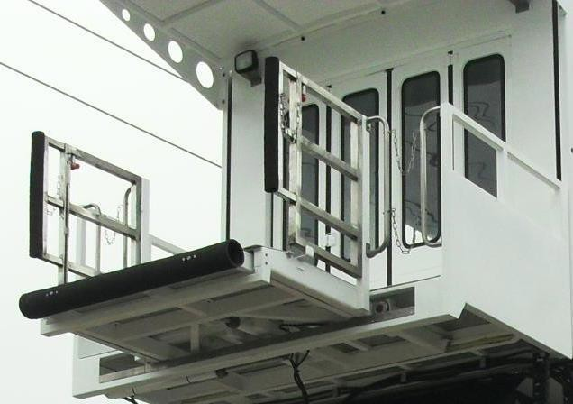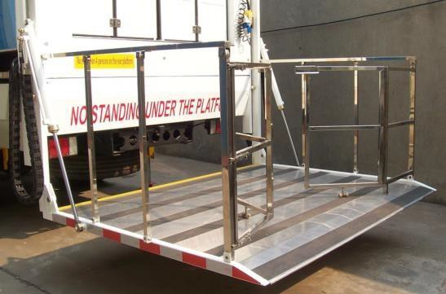

  - Vanbody assembly

    - The van body adopts the special thermal resistant material, and two glass windows are installed on both sides of the van. The inside/outside surface of the van body is the white glass fiber compound plate, and the wall thickness is 45mm. The floor is paved on the skid-resistant floor glue, which is easy for cleaning. There are foldable doors installed in both front and rear end of the van body. The LED lamp and AC10 Air conditioner are installed in the van body. There are fixed wheelchair locating devices and two foldable seats installed in the van body, and one stretcher can be accepted at the same time.

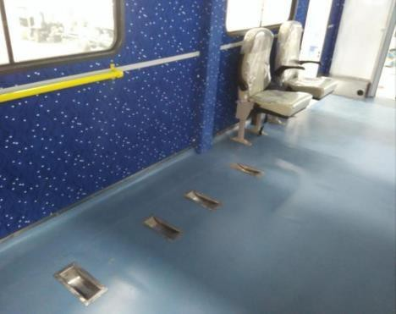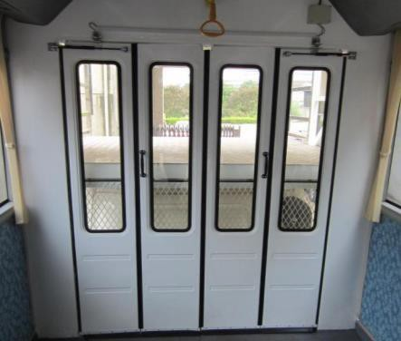

4.4. Scissors assembly

Lift frame is the scissors structure hinged by two rigid beams. The beams are welded by the high-strength rectangle pipe. The extension of the double hydraulic cylinder drives the lift frame, which can achieve the lift of van body.

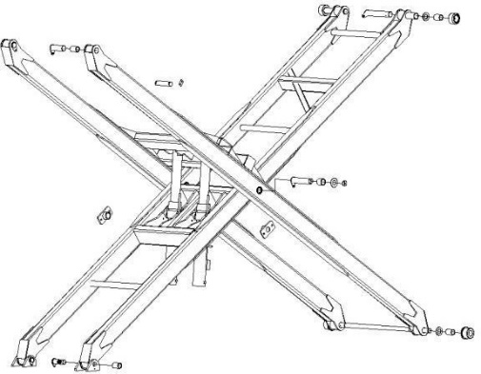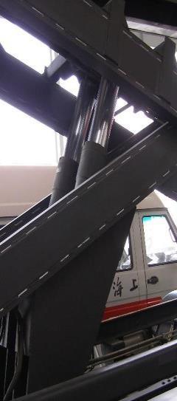

  - Hydraulic system assembly

    - The hydraulic system consists of the oil tank, gear oil pump, emergency electric pump, manual pump, solenoid relief valve, reversing solenoid valve, check valve, hydraulic lock, lift hydraulic cylinder, stabilizer hydraulic cylinder, telescopic platform hydraulic cylinder, etc.

    - When the hydraulic system is in normal operation, the electric system controls the direction of the solenoid valve and all the hydraulic cylinders. When the hydraulic pump cannot work, the emergency electric pump can replace the main hydraulic pump to control the hydraulic movement. When the eclectic system is on failure, the hand pump can control the lifting of the van body and the retracting of the stabilizers.

    - In the hydraulic system, there is the throttle installed in each oil circuit of each movement to adjust the speed of this movement. The oil circuit speed has been settled by the manufacturer, please do not adjust it randomly if it is running well. If there is unusual vibration, please adjust the oil circuit speed to the normal situation. To turn the throttle clockwise, the flow is smaller; to turn the throttle counterclockwise, the flow is bigger.

4.6. Electric control system

The electric control system consists of the operational box, operational panel, control switch, relay, replay box, position check switch, warning lamp, illuminating lamp, outline marker lamp, etc. The entire control system is controlled by the relay, which is easy for maintenance. The voltage is 24V.

4.7. Safety and Interlock system
- When the PTO is engaged, the vehicle cannot move if driver shift the gear.

- The truck cannot be driven if the stabilizer is not retracted fully.

- When the stabilizer is not in the position or the rear platform is not retracted completely, or the van body is not the lowest position, then the van body cannot lift.

- When the van body is not in the lowest position, the stabilizer cannot be retracted and the rear platform cannot move.

- When the front platform is not retracted completely, the van body cannot be lowered.

- When the anti-collision switch of the front platform is touched, the platform cannot move forward.

- When the stabilizer is not retracted completely, or the van body is not in the lowest position, or the rear platform is not retracted completely, then the truck cannot move.

- In the emergency operation, turn the “relieve protection switch” to the “ON” position, then all the hydraulic movement protection will be cancelled.

PAINTING:
  - White color
  - According to the customer’s request

